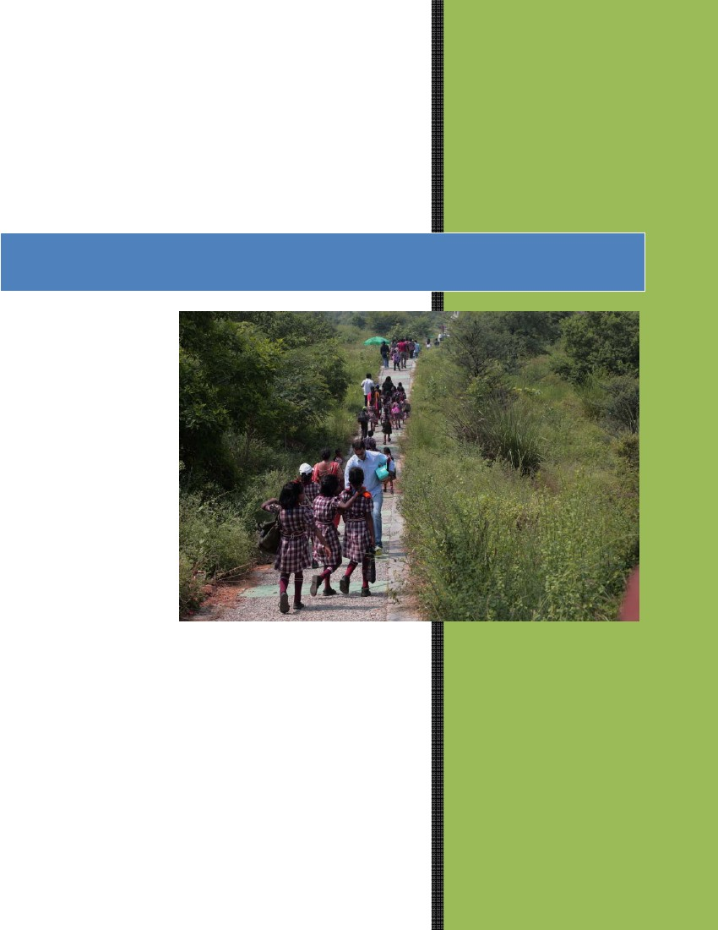
2015
Aravali Biodiversity Park

A report prepared by
iamgurgaon
For
Municipal Corporation of
Gurgaon
Sept 2015

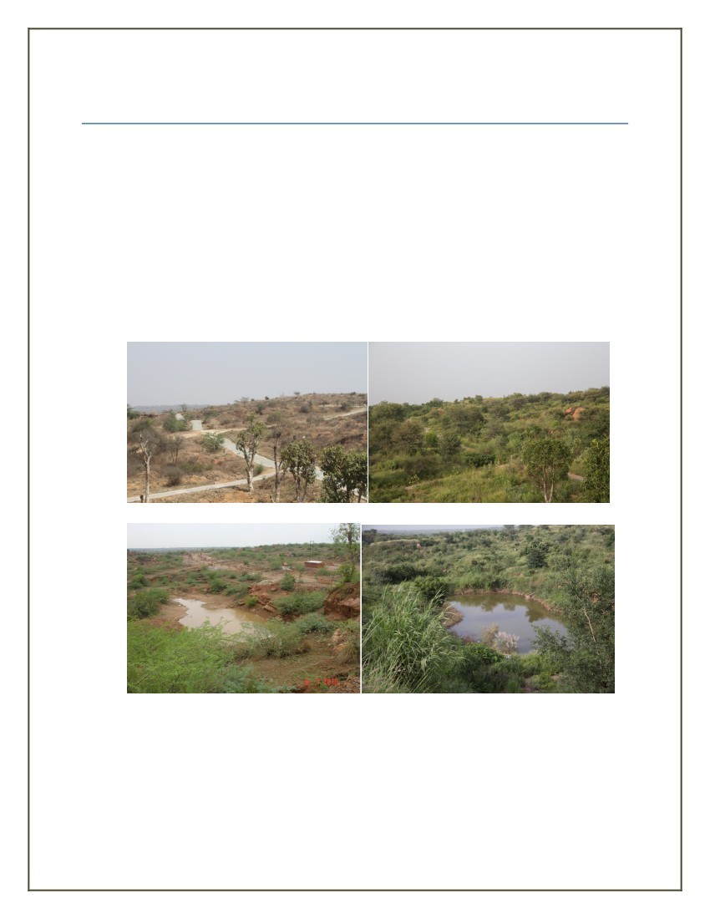
Aravali Biodiversity Park
ORIGIN
•
An IAG (Iamgurgaon) - MCG (Municipal Corporation of Gurgaon) joint initiative: Land
belongs to MCG, infrastructure built by MCG, Plantation and ecological restoration by
Iamgurgaon.
350 acres near Guru Dronacharya Metro Station on the Mehrauli Gurgaon Road.
Earlier a MINING and a MALBA DUMPING site
Native plantations since 2011 have transformed the area into a forest region
MCG granted permission for plantation and maintenance of plantation from 2012 to 2020

2011 2015
•
•
•
•
2011
2015

VISION
The Aravali Biodiversity Park is developed as a habitat showcasing finest forest flora species
of Northern Aravali range. Such as Boswellia serrata (Salai), Sterculia Urens (kullu),
Anogessius pendula (Dhau), Mitragyna parvifolia (Kaim), Wrightia tinctoria (Khirni), Wrightia
arborea (kala indrajao), Holarhenna pubscens (indrajao), Diospyros cordifolia (Bistendu),
Commiphora wightii (Guggul), Helectris isora (Marodphali), Grewia flavescens and many more.
Along with their associate species as they are found in the forests of the Northern Aravali. With
over 400 species of native plants species (trees, shrubs, herbs, climbers and grasses) it is
envisioned as a pristine habitat for birds (resident as well as migratory: close to 180 species
were reported in year 2014) and a habitat for wild animals (civet cat, jackal, neelgai, porcupine,
hare, mongoose including reptiles and insects) of the Northern Aravali.
WATER RECHARGE ZONE: With rapid urbanization and over extraction, ground water is
becoming further scarce in Gurgaon and nearby areas. The groundwater table is receding at the
rate of four feet per year, and these finite reserves are perilously close to being completely
exhausted. The park will work as a large ground water recharge zone. The forest plantation on it
along with soil and water conservation measures this over 350 acres to recharge zone will be a
boon for the Gurgaon region.
EDUCATIONAL SPACE: The park will serve an important role in educating the citizens, especially
children on the significance of Aravali, its flora, fauna, avi-fauna, ecological restoration and
water conservation. The park will sport interpretation centre and in-situ interpretation panels for
raising awareness on the above mentioned subjects. Educational and appreciation walks and
workshops will be conducted regularly in the park for the above purpose.
RECREATIONAL SPACE: The park has an important role of engaging with the citizens in
providing them a recreational space in the natural surroundings. Nature trails, walking tracks,
jogging/bicycling tracks and Amphitheatre are some of the features of the park.

PROGRESS MADE SO FAR
Since 2010, we have come a long way in realizing the Vision of the Aravali Biodiversity Park. A
lot has been achieved and a lot needs to be achieved. Here is what has been done so far.
NATIVE FOREST CREATION:
Nursery Creation: Two large nurseries to propagate native plant species, Aranya and Vanaja
were established in the year 2012. Through these nurseries we have been able to introduce 250
native plant species such as Boswellia serrata, Commiphora wightii, Stercula urens into the
park. As of today we have 250 native plant species in the nurseries.
Plantation: Since start, we have planted upto 100,000plants have been added to the degraded land of the Aravali Biodiversity Park, till 2014. The rocky hills have been planted with Boswellia serrata
and its associate species. Some of the hills are dedicated Anogeissus pendula and its associate
forest species. Valleys have Mitragyna parvifolia and its associates. There are Acacia nilotica
(babool) groves and mixed deciduous forests planted on suitable eco-tones. We have been able to
add 150 species to the park, many of them are either very rare or almost locally extinct from the
Gurgaon region. In this monsoon season another 15000 saplings are being planted.
Fauna and Avi-fauna: There has been a noticeable surge in the population and diversity of
fauna and avi-fauna populations in the park, by providing protection from fire, encroachment and
excessive grazing. A birding group INDIAN BIRDS gave a listing of 180 bird species spotted in
year 2014 at the Park. Many wild animals are frequently spotted by the visitors to the park,
neelgai, jackal, hare, mongoose, monitor lizards are few of them.
Regeneration of species: By stopping cattle grazing and grass cutting there is huge increase in
regeneration of native flora species. Balanities roxburgii, Maytenus seneglensis, Capparis
deciduas are some of the tree species that have shown remarkable recovery. Carissa spinarum,
Maerua oblongifolia, ziziphus nummilaria have also shown good recovery. Stopping people
from cutting grasses has led to good recovery of grasses, 40 species of grasses have been
documented in the park, that have now become a boon for the herbivorous animals, butterflies
and other insects.
WATER RECHARGE ZONE:
Seasonal Ponds: Two large ponds have been constructed in the park in year 2013. They hold
water seasonally and let it seep into the ground slowly, thereby recharging the ground water.
Soil and Water Conservation: A massive soil and water conservation initiative was taken in
year 2014 by MCG by creating slope trenches to check water runoff, in consultation with IAG.
The recovery of flora and extensive planting has also helped in recharging the ground water. The
rain water surface flow does not runoff as fast now, and more is absorbed by the plants and
infiltrates into the ground to recharge the groundwater table. At a very conservative estimate of
recharge of 33% of annual rainfall of approximately 600 mm, ground water recharge is to the

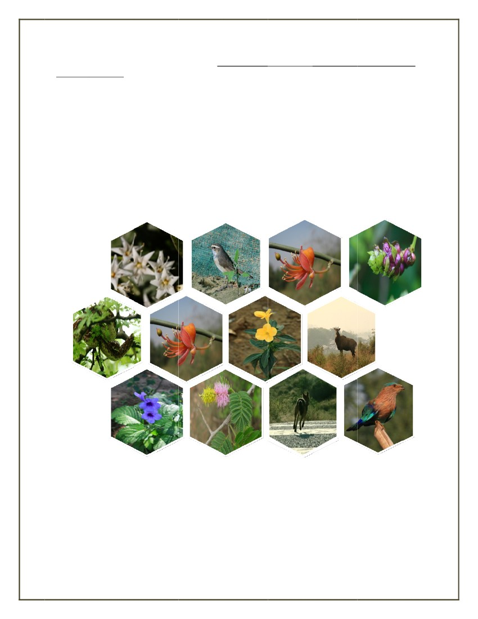
tune of 20 lakh litres per hectare per year. About 3 Crore litres of fre water ge recharged byeeshetsd
the park annually.
Water conservation practices:
Drip Irrigation: The plants are watered optimally from an intensive Drip irrigation network.
Drip irrigation reduces water wastage. Water is only provided for three years, after which plants become self-reliant in tapping ground water.
Sewage Treatment Plant (treated) water: Water for irrigation is sourced from Sewage
Treatment Plants and therefore reduces water stress on ground water.
Mulching Plants after planting plants are mulched well so that the water provided to the plants is not
lost to evaporation.

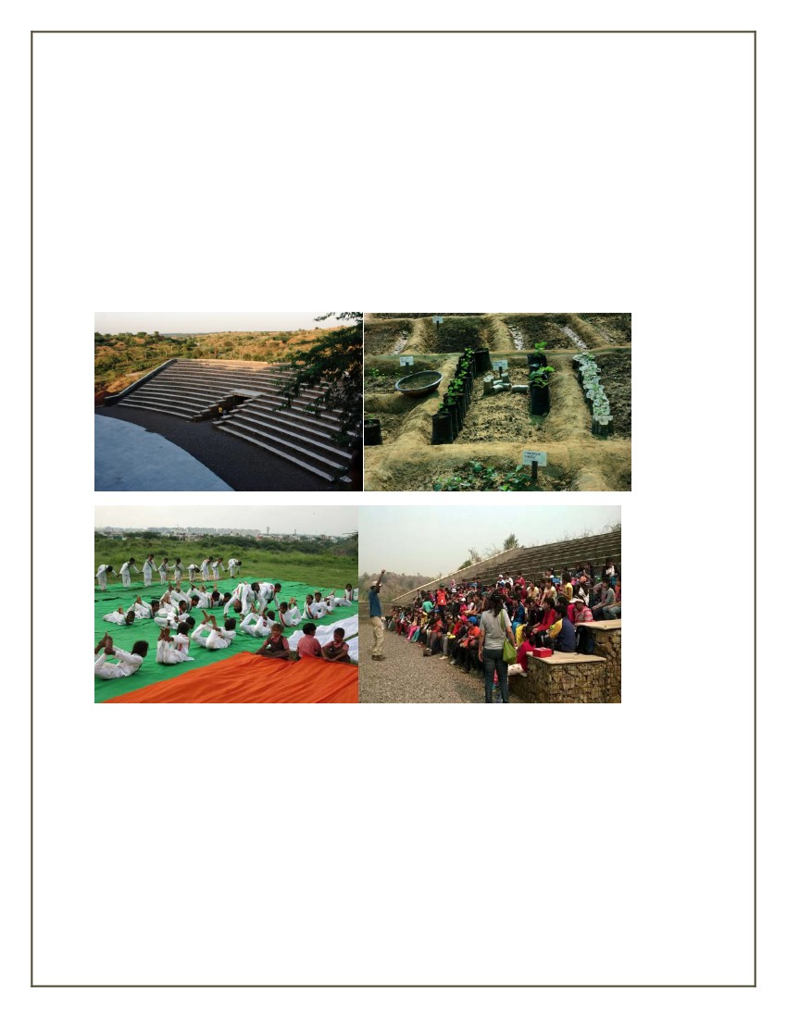
INFRASTRUCTURE
•
•
•
•
•
MCG has created an aesthetic yet cost effective gabion stone boundary wall suited to
terrain in consultation with IAG.
MCG has developed a Car parking that doubles up as water saving zone, largest of its
kind in the NCR in consultation with IAG.
4.5 kilometers of walking trails and cycling trails each, made along naturally occurring
walk paths that were present from before.
Amphitheatre made from naturally available materials that again contributes to water
recharge in consultation with IAG.
Bins for maintaining cleanliness have been put by MCG and IAG at the park.

