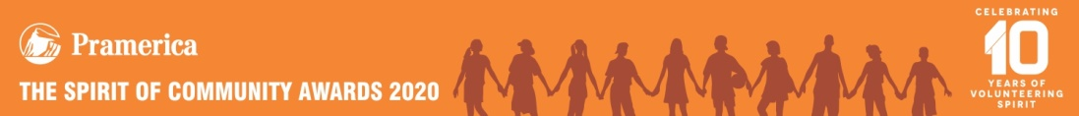
Dear Max,
It is our great pleasure to inform you that you have been selected as one of the top student volunteers in The 2020 Pramerica Spirit of Community Awards - India!
We received around 3,200 applications for this year’s awards program and our judges were so impressed with your service to the community that they chose you to be recognized as a distinguished finalist (Individual Category). This is a great honour for you, your school, and your community. Congratulations!
To salute your accomplishments and honour you with a Certificate of Achievement and an Engraved Silver Medallion, we would like to invite you to an awards ceremony in Delhi on 20th Feb, 2020 at Hotel Holiday Inn, Aerocity. The invitation card is enclosed. We would also like to invite someone from your family - your mother/ father/ guardian - to accompany you for this function. We will announce the names of the national honourees in the evening event.
Allow me to take this opportunity to thank you for your dedication and contribution towards improving lives of others selflessly. The kind of vision and commitment you have demonstrated is extremely rare and very important to the future of our neighbourhood, our cities, and our country. Young volunteers like you are inspiring examples to all of us and are our biggest hope for a better tomorrow.
Again, congratulations on your selection as a distinguished finalist for The 2020 Pramerica Spirit of Community Awards India. We look forward to seeing you on February 20^{th.}
Sincerely,
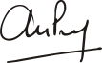
Anoop Pabby
Managing Director and CEO
Pramerica Life Insurance Company Limited

